**Front End Engineering-II**

Project Report Semester-III (Batch-2023)

SAARTHI



## Supervised By: Submitted By:

Mahesh Prasad Ridhi Bhatia (2310990946)

Samriti Chauhan (2310990958)

# Department of Computer Science and Engineering Chitkara University Institute of Engineering & Technology,

**Chitkara University, Punjab**

**Abstract**

This project “SAARTHI” is used to automate all processes of travel and tourism, related to the creation, booking confirmation, and user details. Travel and tourism management system is used to book a tour from anywhere in the world by a single dynamic website which will help the user to know about all the places and tour details in a single website. Admin can add packages from certain travel agents and hotels to the website by creating a tour page. Users can then sign in and book each project, confirmed by the admin on their booking management page. Users can view the confirmation on their My Bookings page. It is the easiest platform for all the passengers to book easily and know all the details.

**Table Of contents**

|  |  |  |
| --- | --- | --- |
| S.No | Section | Page No. |
| 1. | Introduction   * 1. Background   2. Literature Reviews   3. Objectives   4. Significance | 4-5 |
| 2. | Problem definition and requirements | 6 |
| 3. | Methodology | 7 |
| 4. | Results | 8-11 |

1. **Introduction**

1.1 Background

Tourism and the travel industry play an important role in the development of the country’s economy. Many countries around the world are completely dependent on tourism for their existence. Tourism is seen from the point of view of both business and leisure and travel is the medium by which a tourist travels from one place to another. hence both tourism and travel are related to each other. tourists want to travel to far-flung places in search of nature, adventure, and health. various types of tourism exist around the world to fulfill such desires and these desires are mostly fulfilled by physically traveling to desired destinations where means of travel come into play. when it comes to travel, there are travel agents, tour operators, tourist guides, travel desks in hotels, etc., who provide and manage travel and other services to their customers and generate revenue for themselves. This makes both tourism and travel industry interdependent. a person who wants to study tourism and make a career in tourism is expected to have a sound knowledge of different modes of transport around the world. The travel and tourism management system are used to book a tour from anywhere in the world through a single dynamic website that will provide the user with all of the information about the sites and tour specifics in one spot. By creating a tour page, the administrator can add packages from certain travel agencies and hotels to the website. The users may then log in and book each project, which the admin can confirm on their manage booking page. The confirmation can be seen on the user's booking page. It is the simplest platform for all travelers to book and learn about all the information. A dynamic website for the tourism industry is the Tour Management System. It's a responsive and dynamic site design. It's also known as a travel technology solution for tour operators and agencies. Almost everyone goes on vacation, so a tourism management system would be quite useful in preparing the ideal trip.

* 1. Literature Review

1. <https://wouldbewanderer.com/> : This online travel website does not offer bookings for planned places or destinations. Another drawback of this site is the absence of a complaint box where customers can express dissatisfaction with their bookings. In contrast, our website provides secure booking facilities and a complaint box for customers to share their feedback.
2. [https://realitytoursandtravel.com/#](https://realitytoursandtravel.com/) : Their website only provides places within India, limiting their offerings. In contrast, our website will provide a wide range of destinations and vacation packages both within India and abroad, all at affordable prices.
3. <https://www.yatra.com/holidays> : The interface on this site is very congested, making it very difficult to navigate and find necessary information. However, our site will provide a user-friendly interface that will ensure customers do not feel frustrated while using it.
   1. Objectives

* Easy cancellation with refund will be available: Users can easily cancel their bookings through our website, a feature that is often unavailable on other sites and can be very frustrating for customers.
* User-friendly interface: Customers will be able to book their destinations using any device, such as phones, laptops/PCs, tablets, and more, making the booking process convenient and accessible from anywhere.
* Increase Customer Loyalty: As mentioned in point 1, our website provides both cancellation and refund options, so customers can fully rely on our website without hesitation. With this approach, we aim to enhance customer loyalty and retention.
  1. Significance

Our site 'SAARTHI' serves as a one-stop platform for users to research, plan, and book their travel experiences. It provides convenience and accessibility by offering a wide range of destinations, personalized recommendations, secure booking options, and valuable insights through user-generated reviews and destination guides. Additionally, it can be a valuable tool for promoting global tourism, fostering cultural exchange, and facilitating memorable travel experiences for individuals and families.

1. **Problem Definition and Requirements**

The travel and tourism industry is growing rapidly, but many websites lack user-friendly interfaces, accurate information, and personalized experiences, leading to frustrated users and missed business opportunities.

Requirements:

1. User-Friendly Interface:

- Simple navigation and effective search features

- Clear and concise content presentation

- Optimized for mobile devices

2. Accurate Information:

- Updated travel guides for various destinations

- Dependable booking details and pricing

- Real-time availability and itineraries

3. Personalized Experience:

- User profiles and tailored preferences

- Customized suggestions and recommendations

- Personalized promotions and special offers

4. Destination Guides:

- Detailed information about different destinations

- High-quality visual content, including images and videos

- User-generated reviews and ratings

5. Booking and Payment:

- Secure processing of payments

- Convenient booking and cancellation procedures

- Transparent policies and associated fees

6. Community Features:

- User forums and interactive discussion boards

- Integration with social media platforms

- Access to travel blogs and informative articles

7. - Build the website using HTML, CSS, JavaScript, and ReactJs technology stack

1. **Methodology**

To address the requirements and solve the problem, we will follow a user-centered design and agile development approach:

1. Design:

- Create an attractive and intuitive design for a better user experience

2. Development:

- We will use HTML and CSS for the first evaluation and after that we’ll use JavaScript for the second evaluation. Last but not least we will use ReactJs for the final evaluation.

- Ensure responsiveness for optimal performance across mobile devices

3. Maintenance and Updates:

- Consistently update content and functionalities

- Monitor analytics and user input to make ongoing improvements

4. Launch and Deployment:

- Organizing and executing a seamless deployment process

- Setting up analytics and tracking tools

- Performing a review and making improvements after the launch

**4 Results**

4.1 Home page

The below figure shows our home page of our website in which user can navigate the various sections such as Destinations, Guide, Blog, Discover More and even they can Contact Us if he faces any kind of issue.

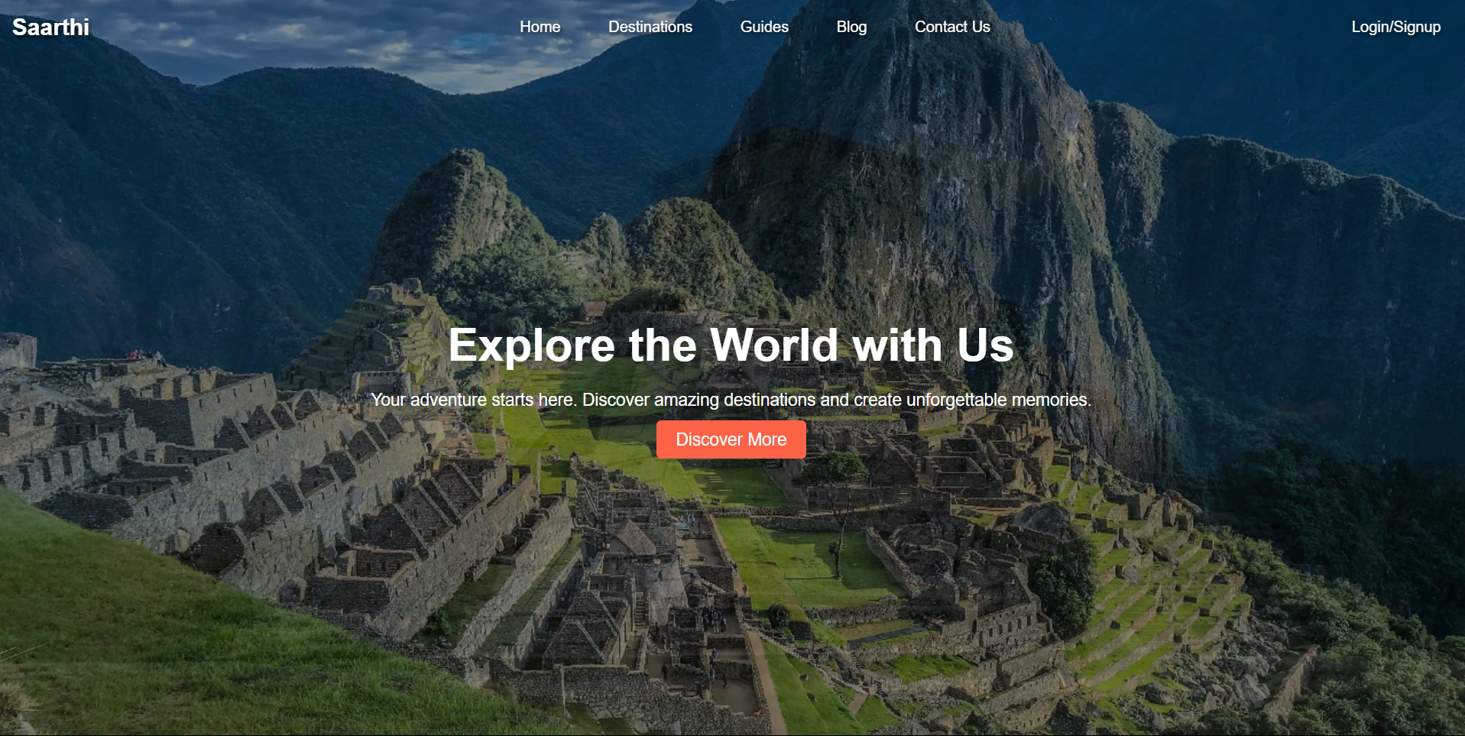

4.2 Destination

The below figure shows the destinations page of our website in which user can explore various Domestic or International places for travelling by clicking on Explore More button. 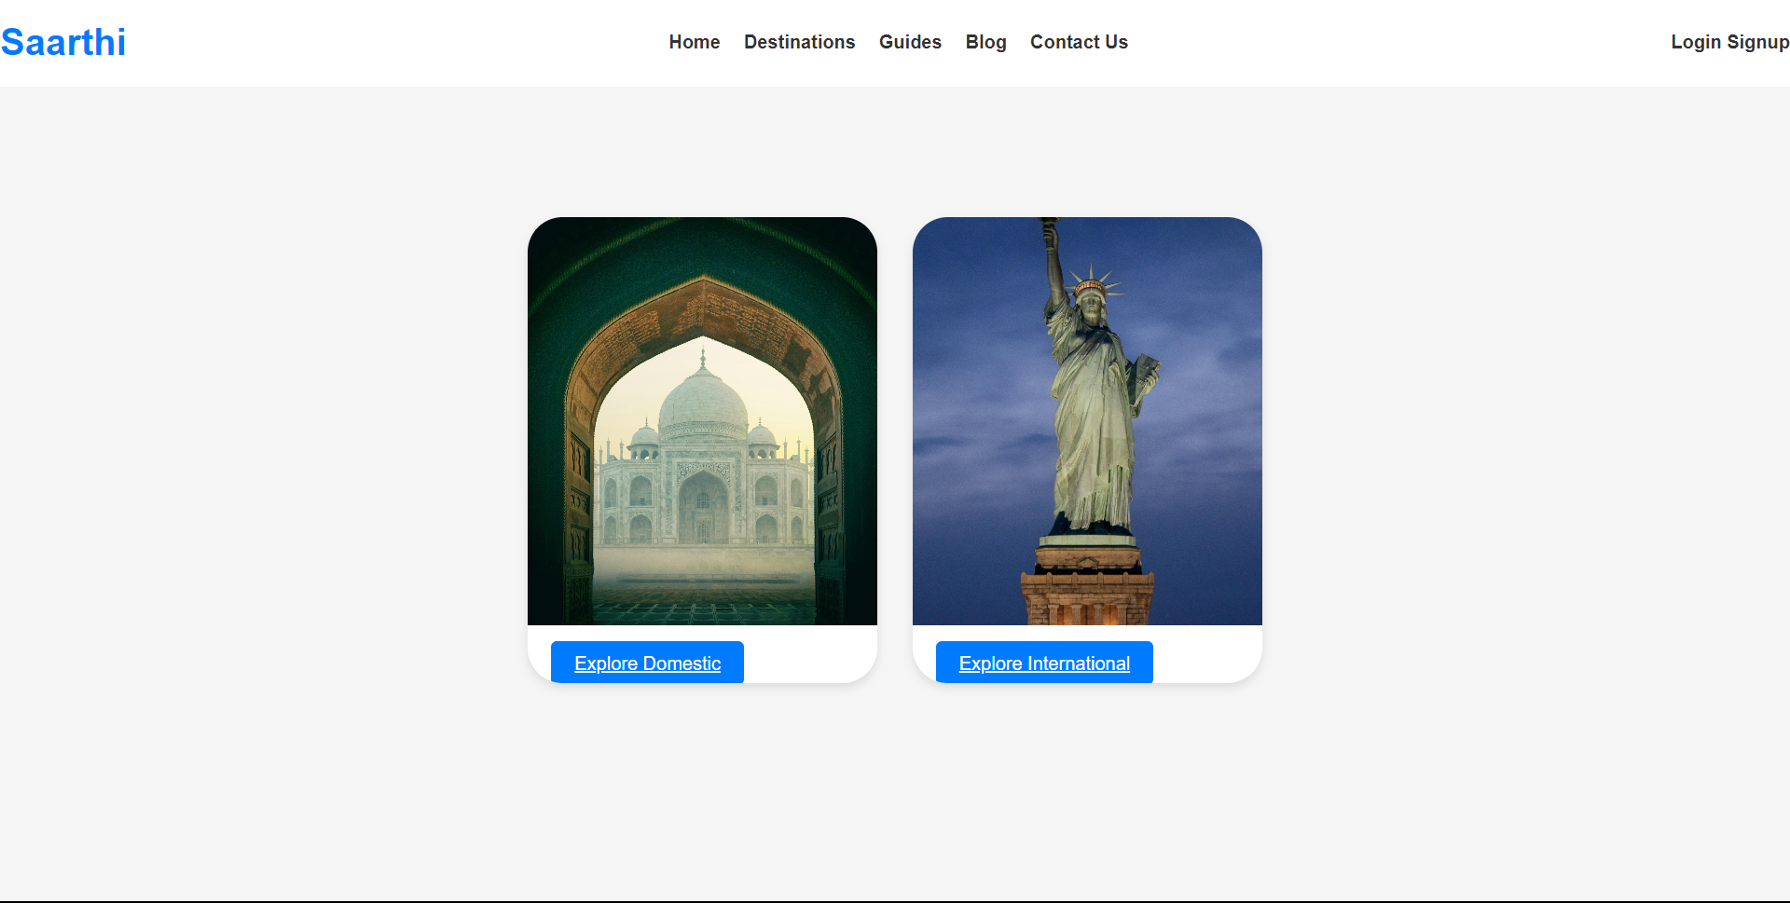

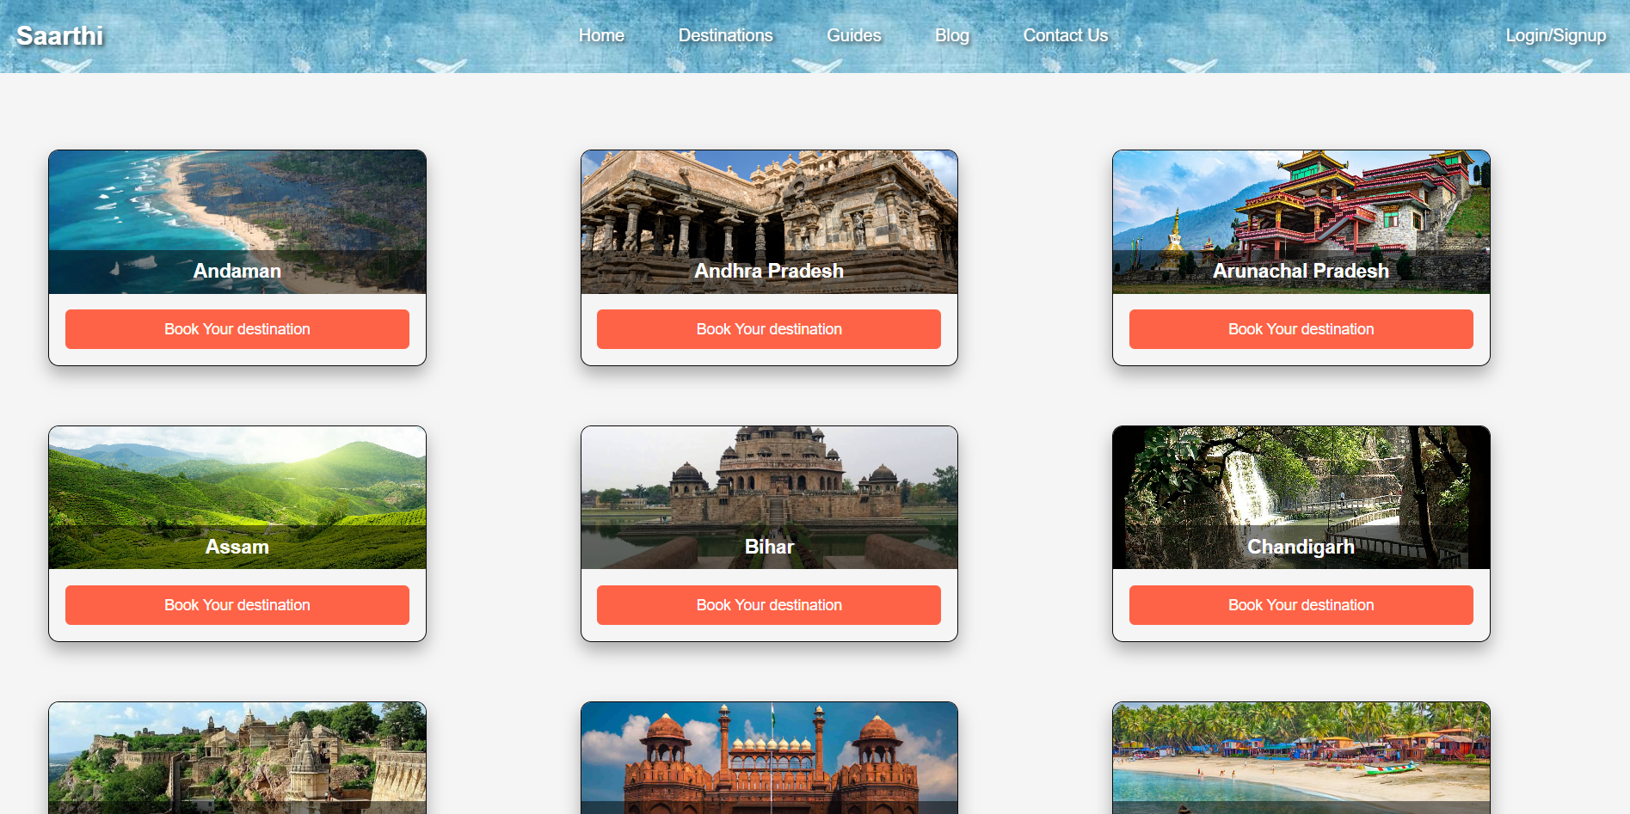

Domestic Page

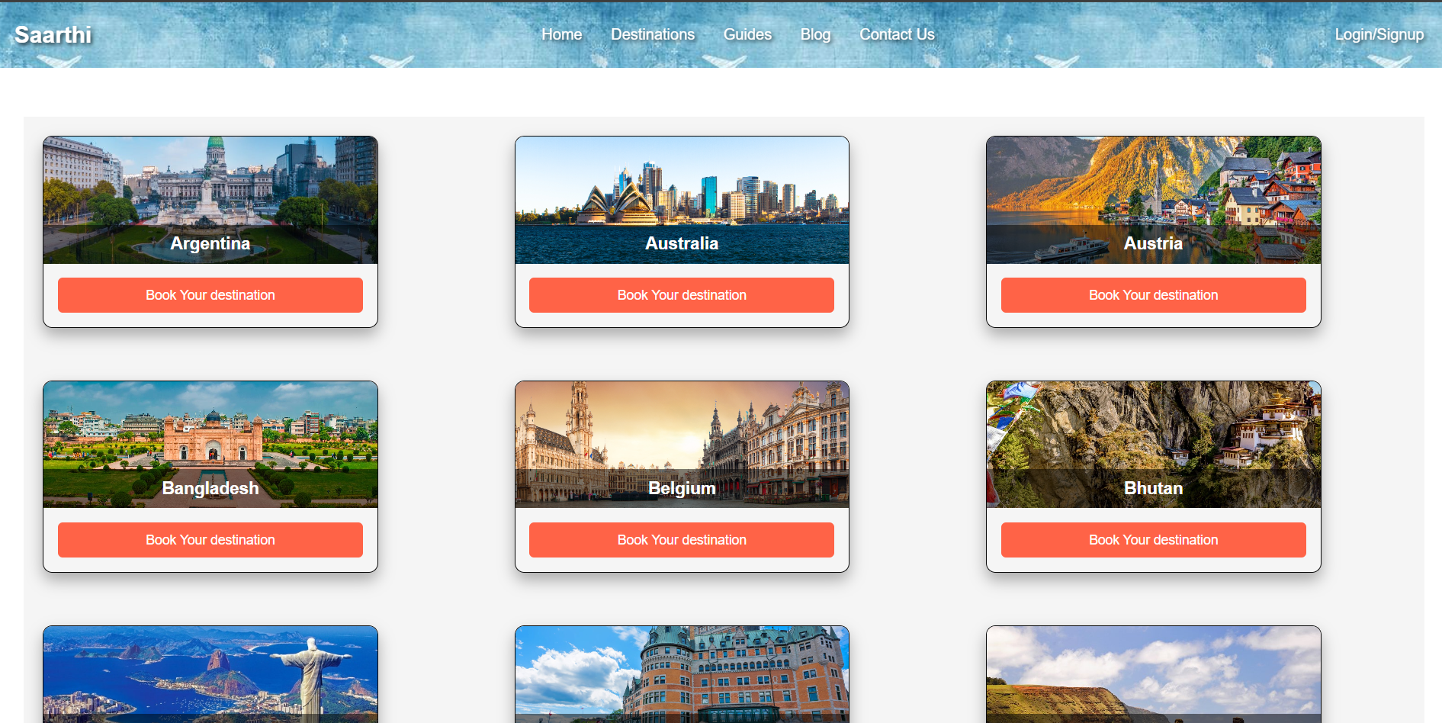

International Page

4.3 Contact Us

In this page the user can contact us through various modes.

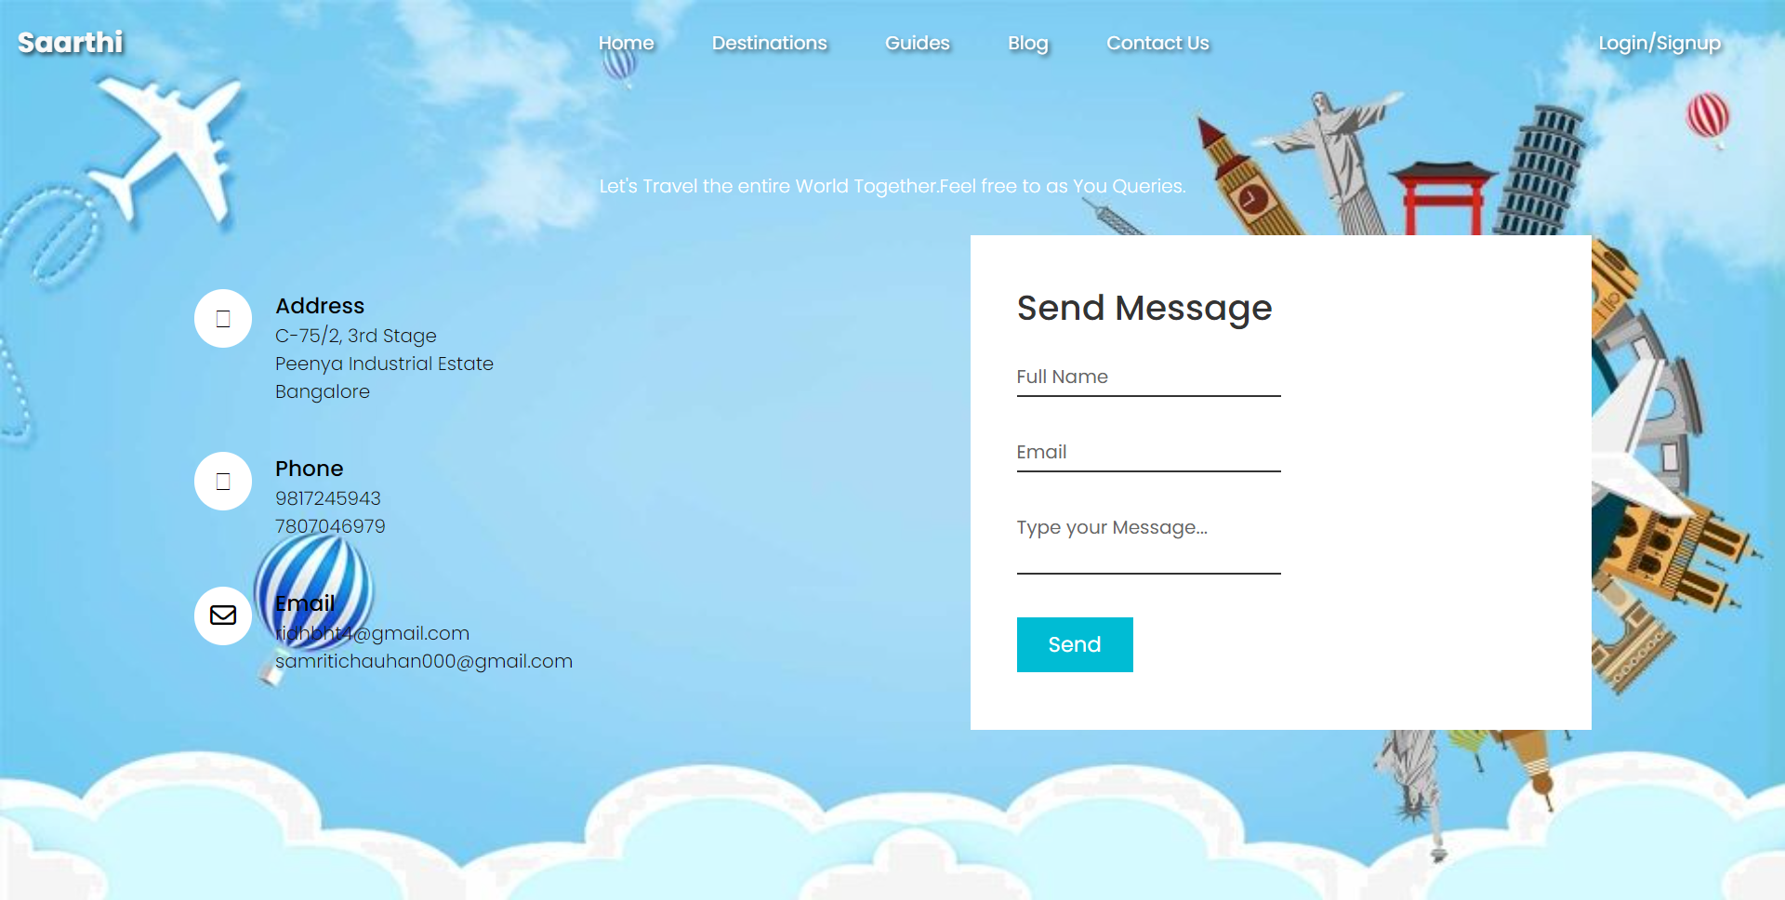

4.4 Login/Signup page

This page allows user to login/signup their ids.

